# Microservices with Spring Boot 3 and Spring Cloud

# Microservices with API gateway

# Additional HandsOn

**Create Eureka Discovery Server and register microservices**

Eureka Discovery Server holds a registry of all the services that are available for immediate consumption. Anybody whom wants to consume a RESTful Web Service can come to the discovery server and find out what is available and ready for consumption. Eureka Discovery Server is part of spring cloud module. Follow steps below to implement:

1. **Create and Launch Eureka Discovery Server •**

Using https://start.spring.io generate a project with following configuration:

**Group:** com.cognizant

**Artifact:** eureka-discovery-server

**Module:** Spring Cloud Discovery > Eureka Server

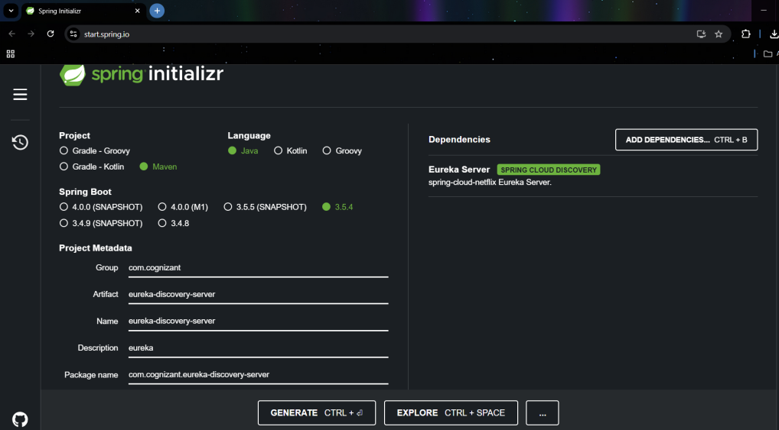

**mvn clean**

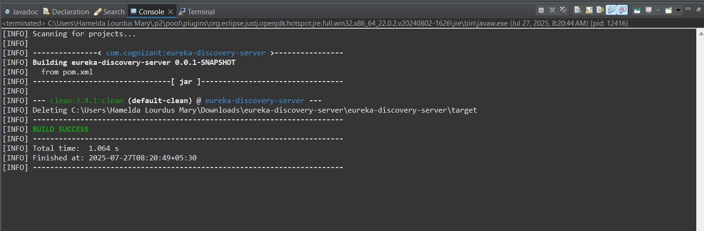

**EurekaDiscoveryServerApplication.java**

package com.cognizant.eureka_discovery_server;

import org.springframework.boot.SpringApplication;

import org.springframework.boot.autoconfigure.SpringBootApplication;

import org.springframework.cloud.netflix.eureka.server.EnableEurekaServer;

@SpringBootApplication

*@EnableEurekaServer*

public class EurekaDiscoveryServerApplication {

public static void main(String[] args) {

SpringApplication.run(EurekaDiscoveryServerApplication.class, args);

}

}

**application.properties**

spring.application.name=eureka-discovery-server

server.port=8761

eureka.client.register-with-eureka=false

eureka.client.fetch-registry=false

logging.level.com.netflix.eureka=OFF

logging.level.com.netflix.discovery=OFF

**Run the application:**

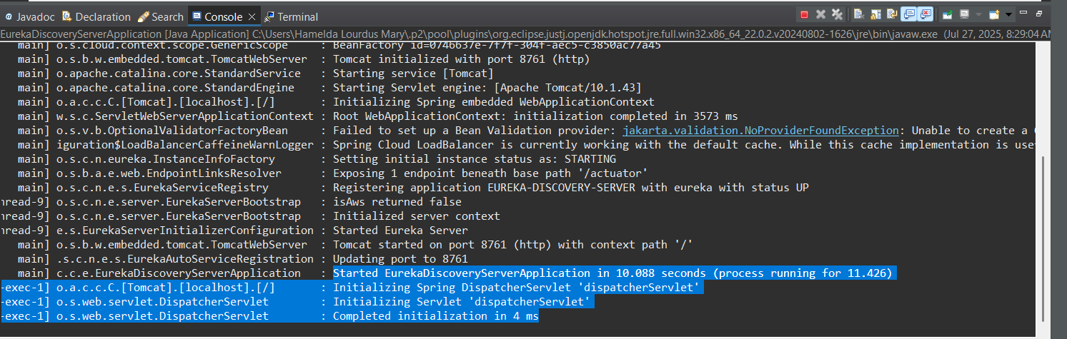

<http://localhost:8761/>

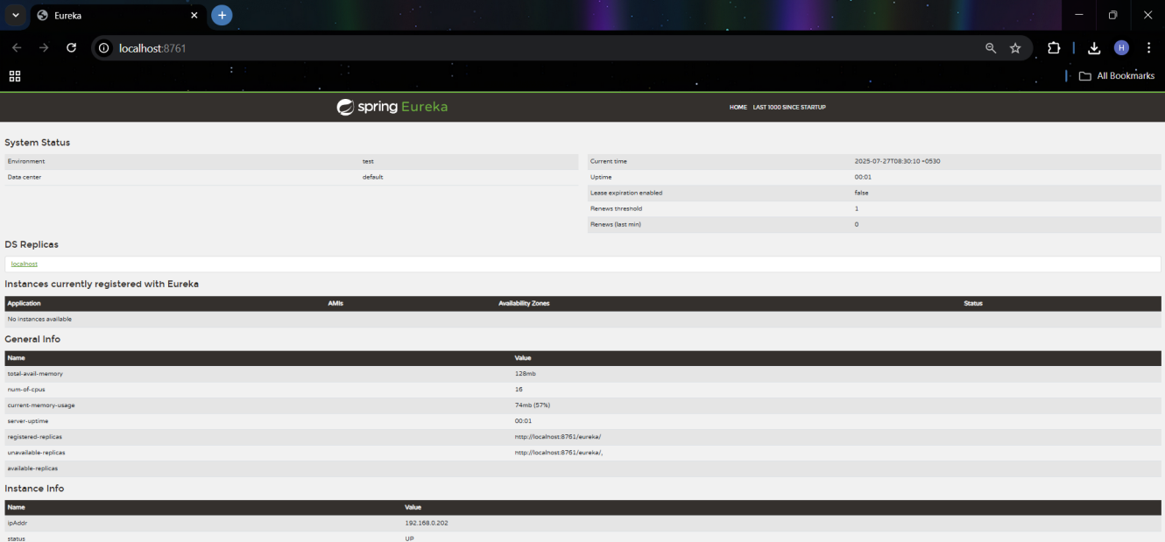

**Look into the section**

"Instances currently registered with Eureka", which will have an empty list

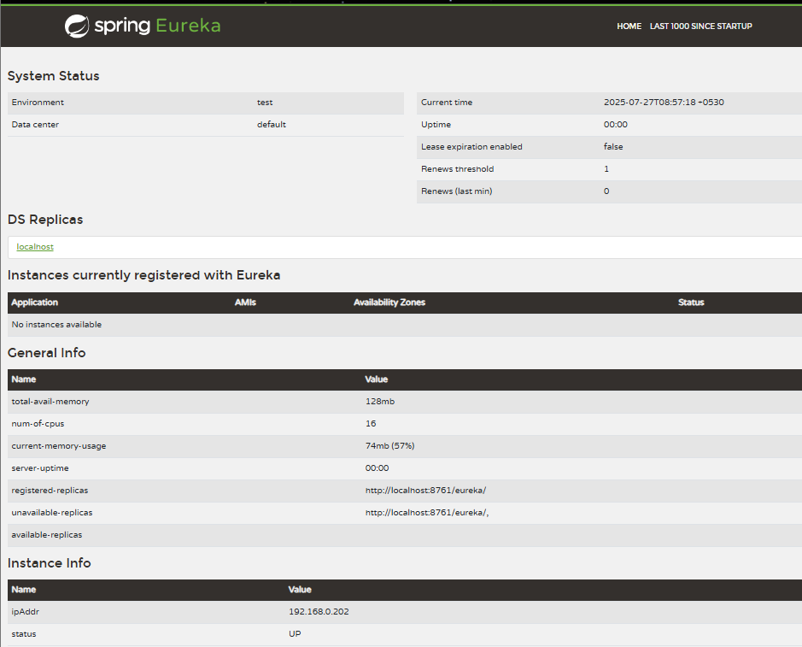

**Register Account REST API to eureka discovery**

**Go to https://start.spring.io and provide the following configuration:**

**Group:** com.cognizant

**Artifact:** accounteureka

**Modules: ▪**

Spring Boot DevTools ▪

Eureka Discovery Client ▪

Spring Web

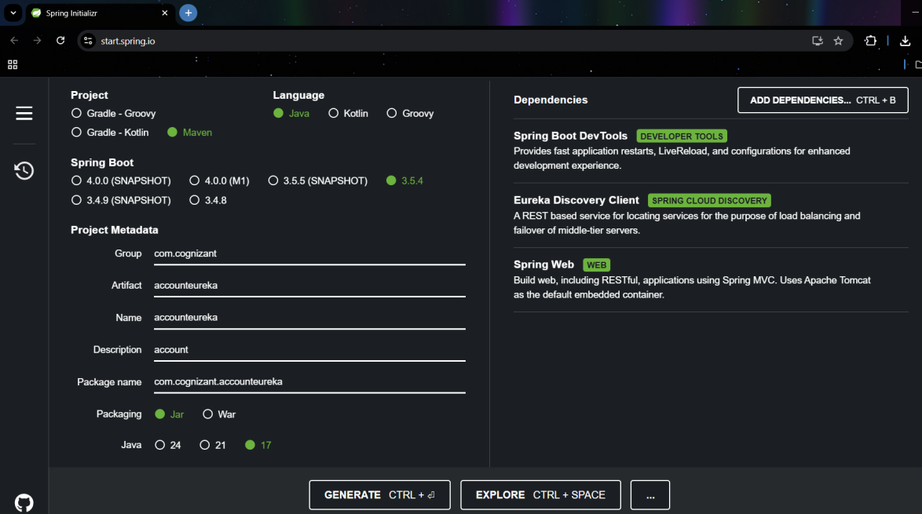

**mvn clean**

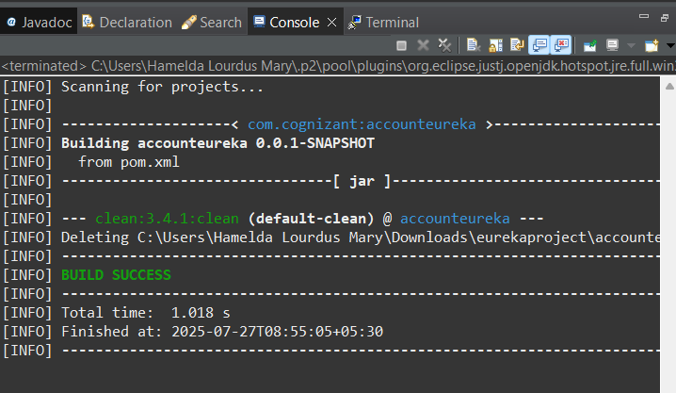

**mvn install**

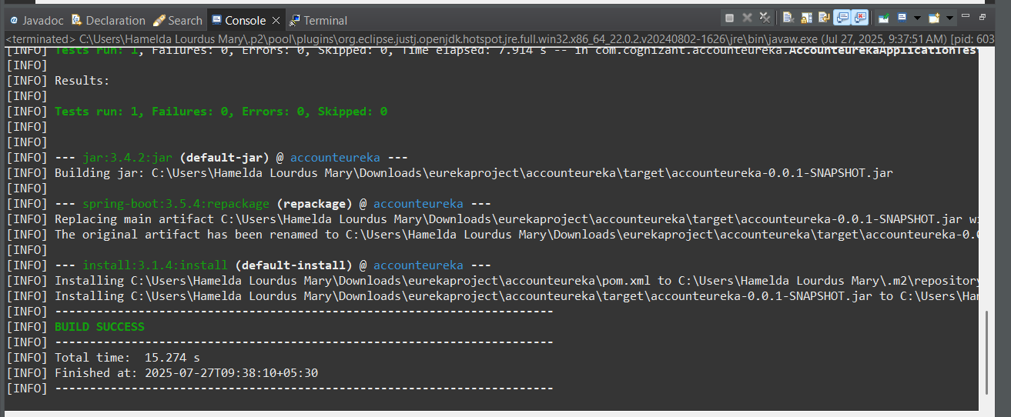

**AccounteurekaApplication.java**

package com.cognizant.accounteureka;

import org.springframework.boot.SpringApplication;

import org.springframework.boot.autoconfigure.SpringBootApplication;

import org.springframework.cloud.client.discovery.EnableDiscoveryClient;

@SpringBootApplication

@EnableDiscoveryClient

public class AccounteurekaApplication {

public static void main(String[] args) {

SpringApplication.run(AccounteurekaApplication.class, args);

}

}

**Application.properties**

*spring.application.name=account-service*

eureka.client.service-url.defaultZone=http://localhost:8761/eureka/

server.port=8082

**Run the application:**

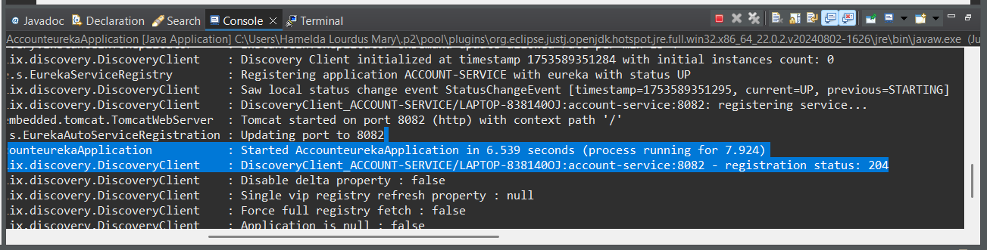

<http://localhost:8761>

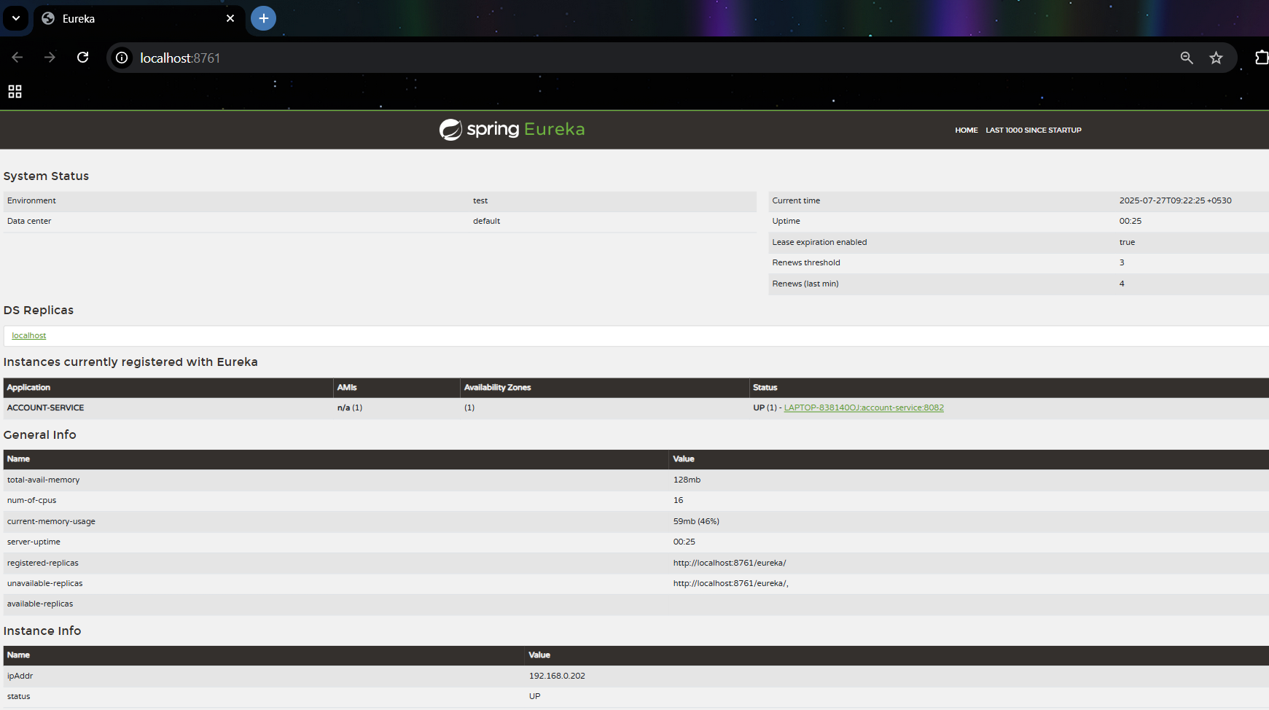

**Refresh the eureka-discovery-server web page in browser,**

the accountservice will be listed in the registry

